Supplementary material
Graphic presentation of the EDS measurements in the samples shown in Figure 2.
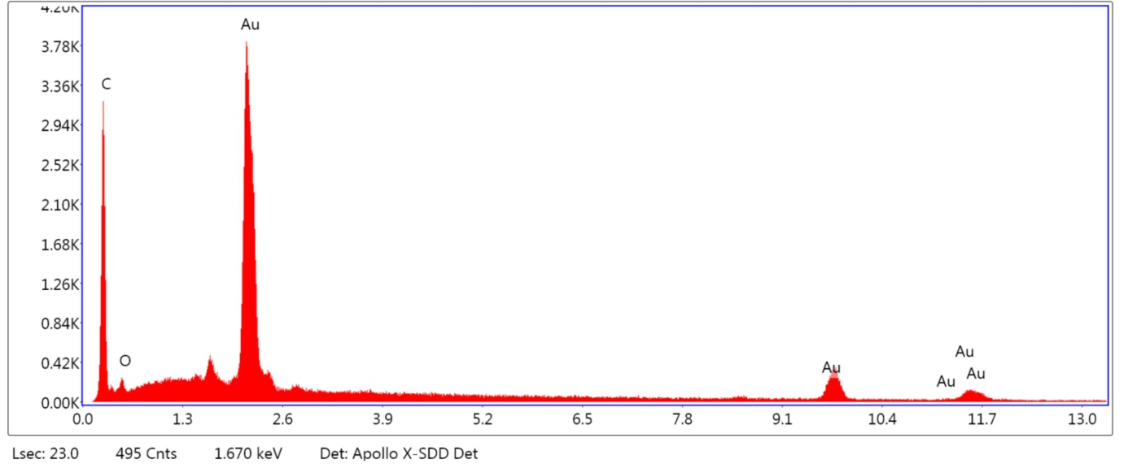
1) Figure 2A – spot 1

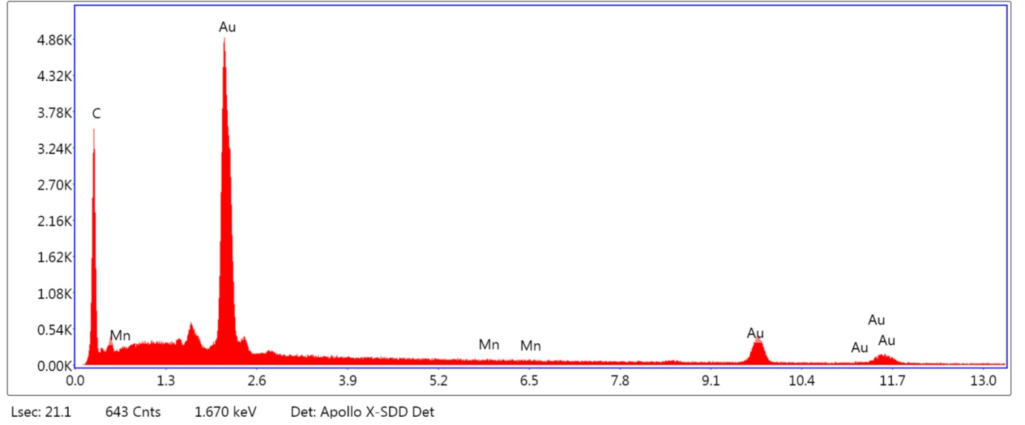
2) Figure 2A – spot 2
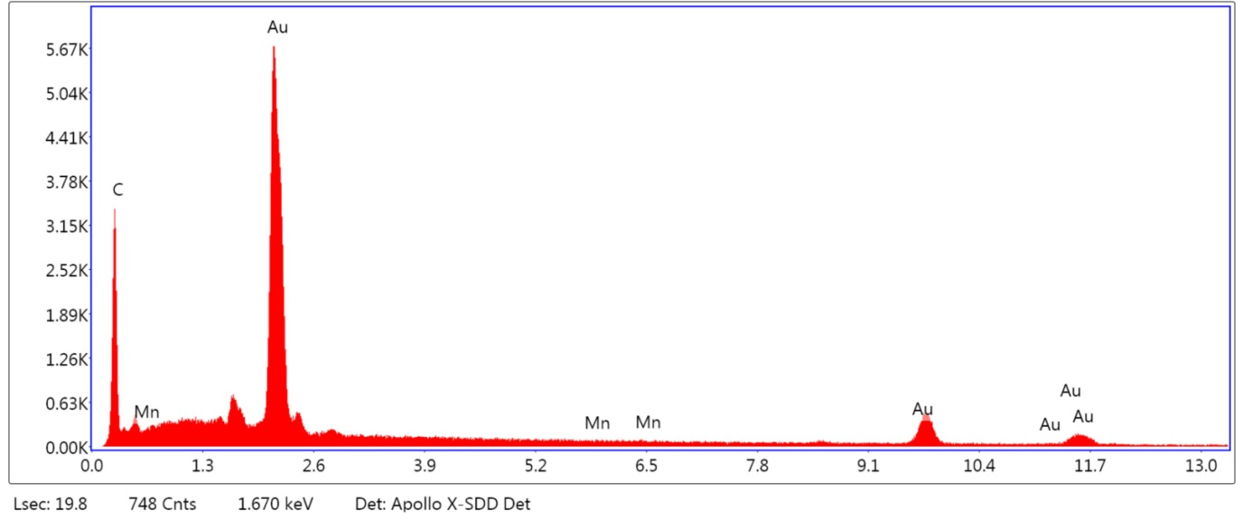
3) Figure 2A – spot 3

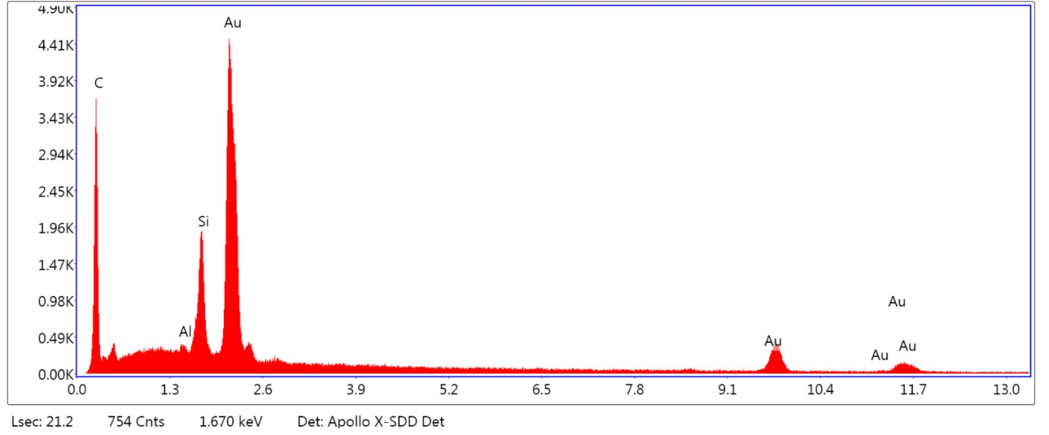
4) Figure 2A – spot 4

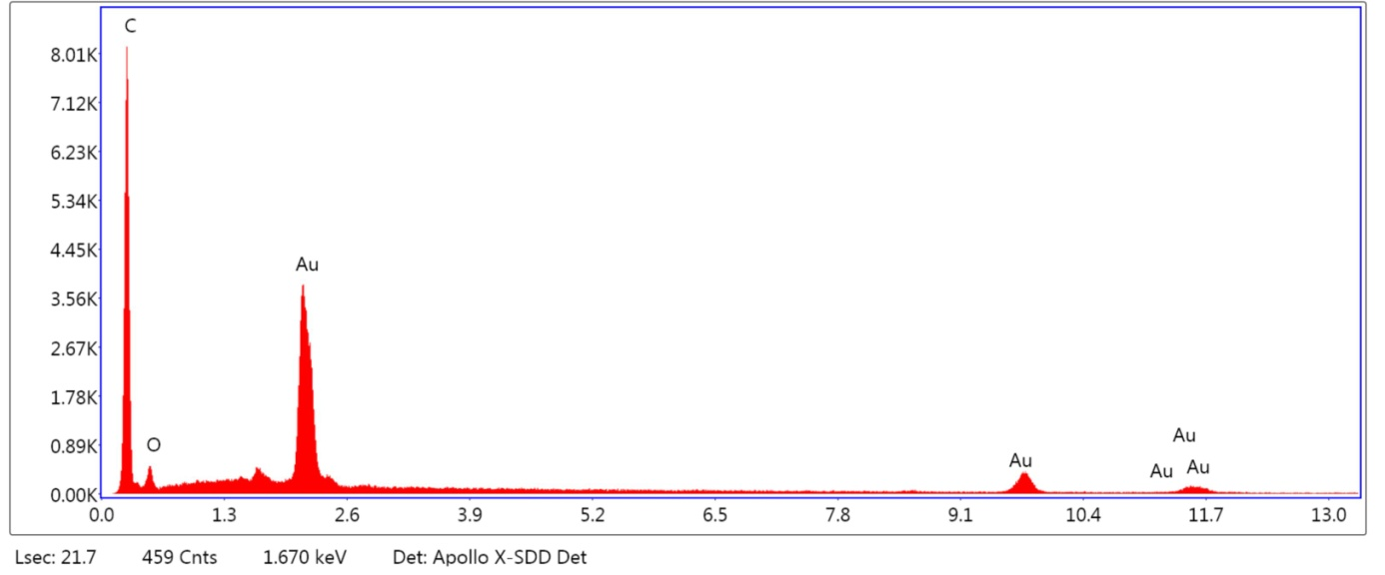
5) Figure 2A – spot 5

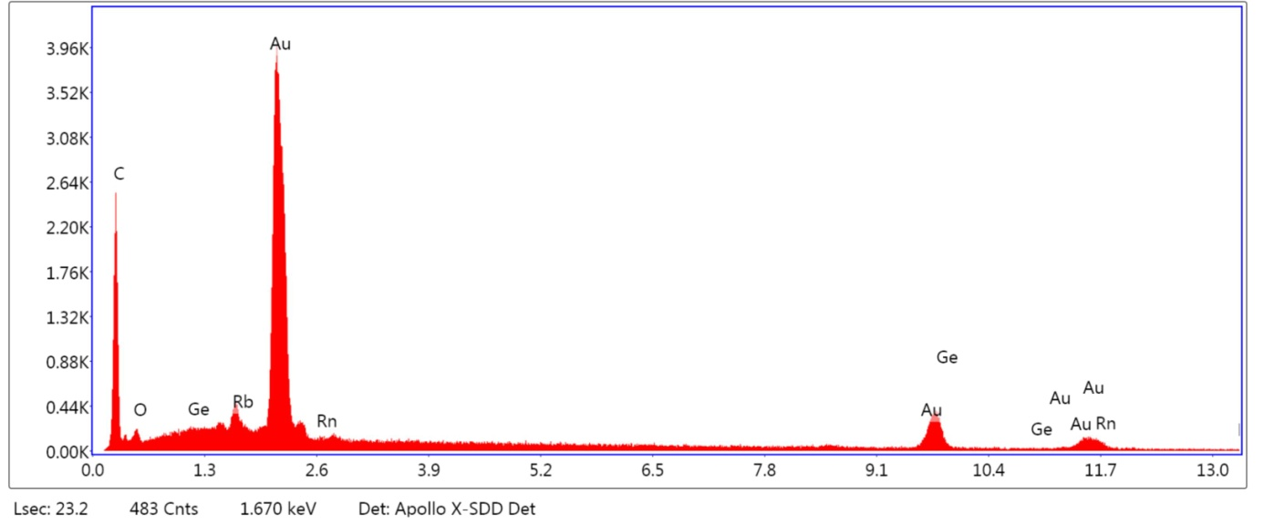
6) Figure 2B – spot 1

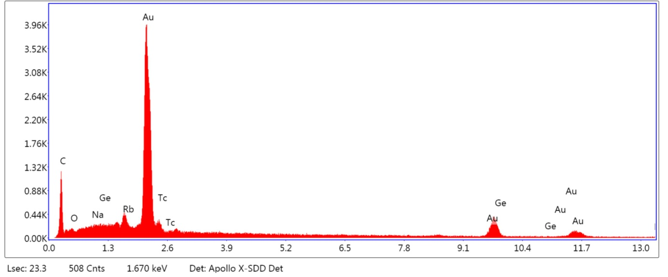
7) Figure 2B – spot 2

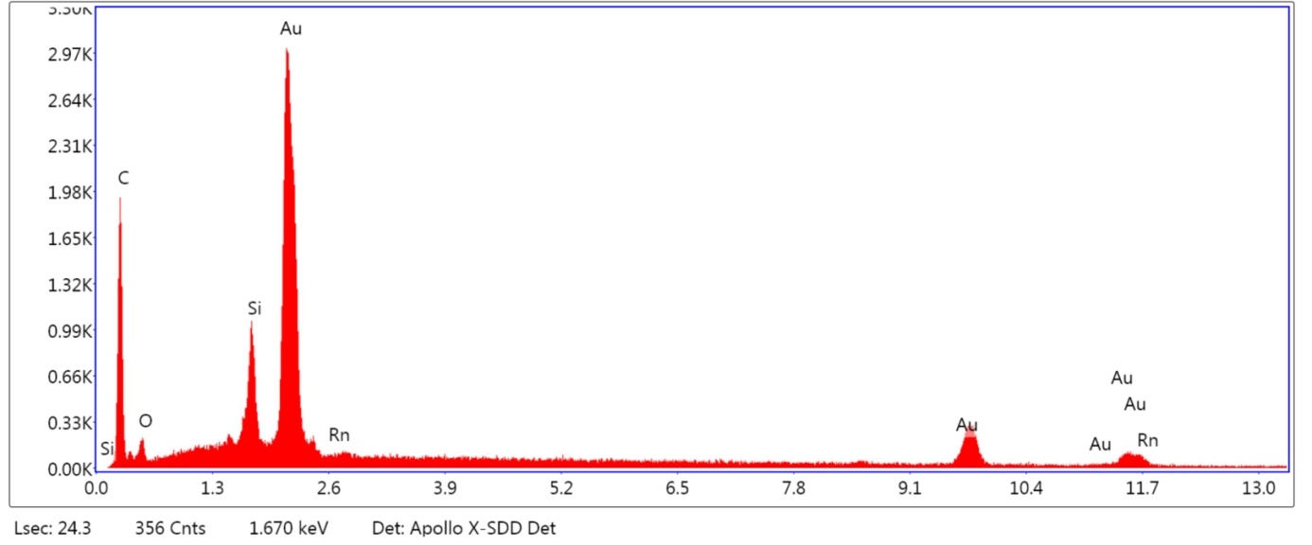
8) Figure 2B – spot 3

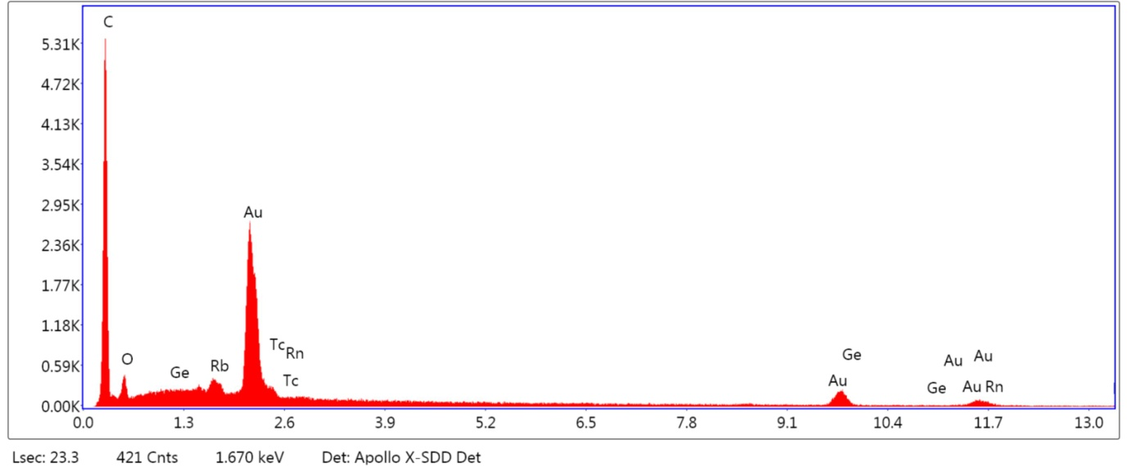
9) Figure 2C – spot 1

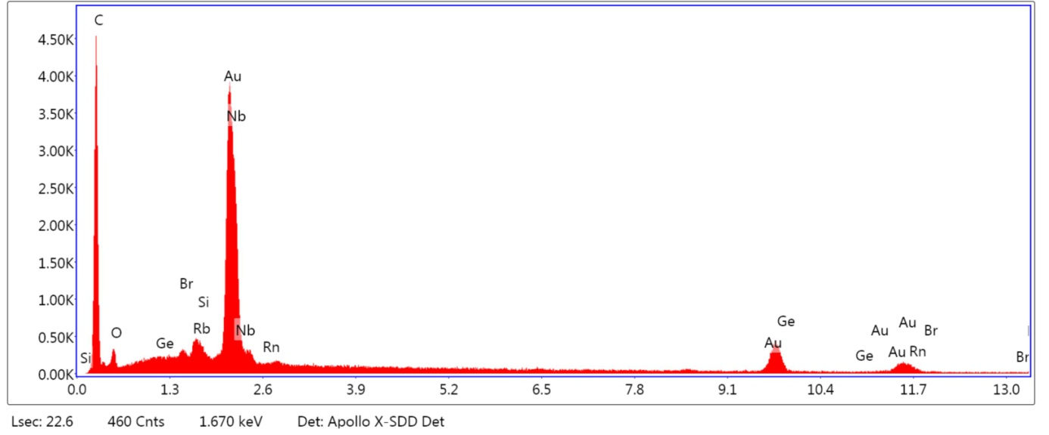
10) Figure 2C – spot 2

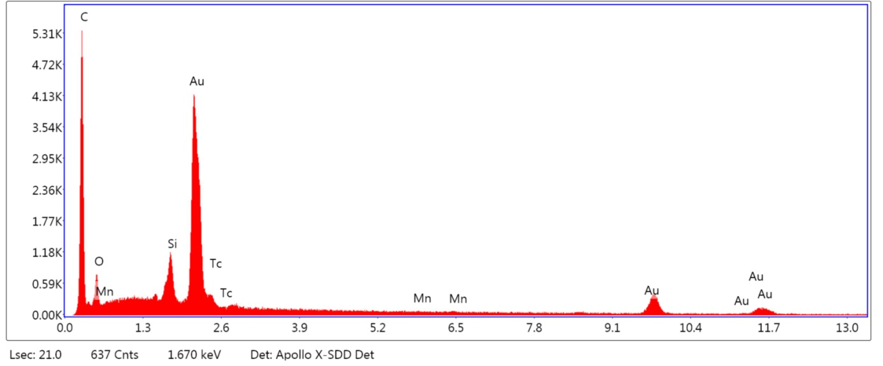
11) Figure 2D – spot 1

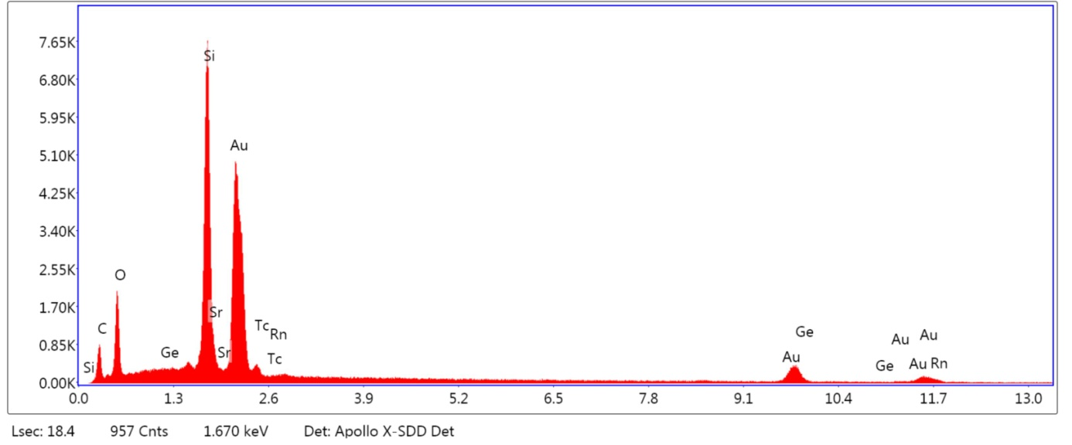
12) Figure 2D – spot 2

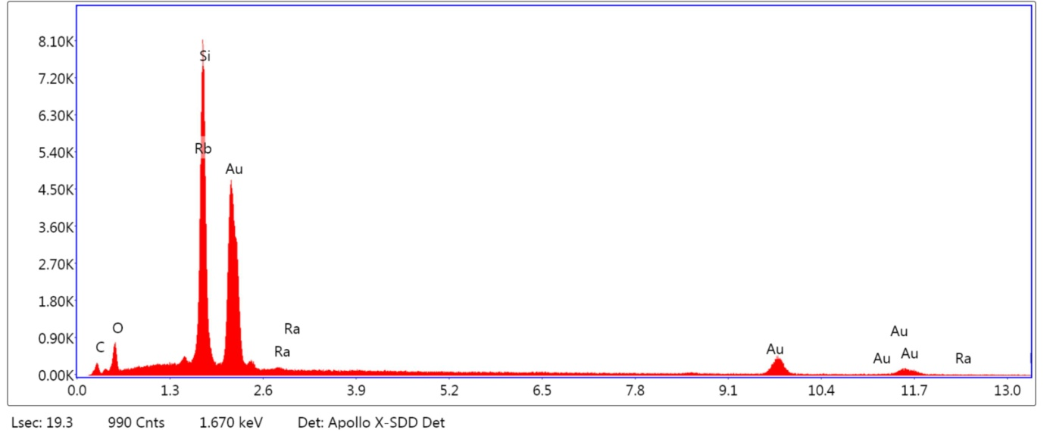
13) Figure 2D – spot 3

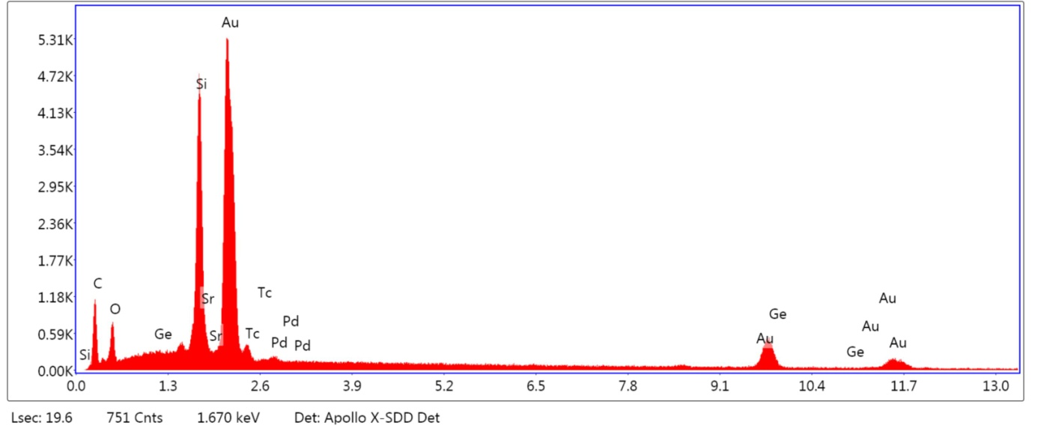
14) Figure 2D – spot 4

